# Code

## Dependencies

1. Spring for apache kafka 2) spring for apache kafka streams,3) cloud stream 4) spring for reactive web

Sample producer beans

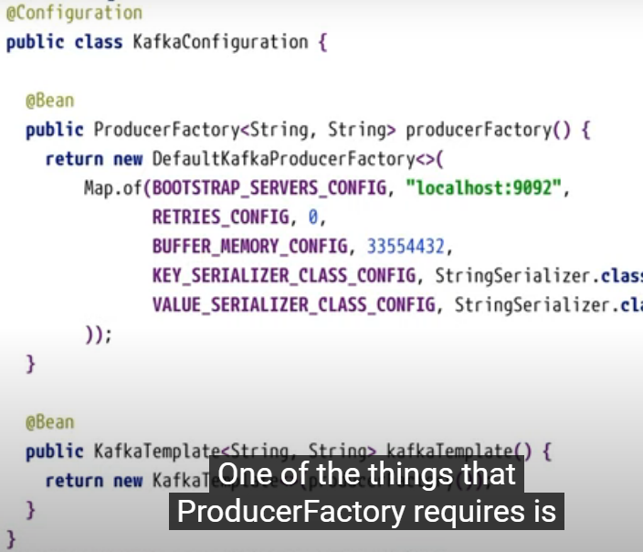

To generate some messages use dependency

Gradle dependency

https://github.com/DIUS/Java-faker

<dependency>

<groupId>com.github.javafaker</groupId>

<artifactId>javafaker</artifactId>

<version>1.0.2</version>

</dependency>

dependencies {

implementation 'com.github.javafaker:javafaker:1.0.2'

}

## Consumer Retries

<https://github.com/manideep-vv/Forked-spring-kafka/blob/main/samples/sample-04/src/main/java/com/example/Application.java>

@RetryableTopic(attempts = "5", backoff = @Backoff(delay = 2_000, maxDelay = 10_000, multiplier = 2,exclude=…,include=…))

@KafkaListener(id = "fooGroup", topics = "topic4")

public void listen(String in, @Header(KafkaHeaders.RECEIVED_TOPIC) String topic,

@Header(KafkaHeaders.OFFSET) long offset) {

this.logger.info("Received: {} from {} @ {}", in, topic, offset);

if (in.startsWith("fail")) {

throw new RuntimeException("failed");

}

}